**Title:**

Familiarization with an STM32, the study of blink test and implementation of a light controlling system using microcontrollers.

**Theory and Methodology**:

STM32CubeIDE stands as a sophisticated development platform tailored for C/C++ programming, specifically designed for STM32 microcontrollers and microprocessors. It integrates comprehensive features such as peripheral configuration, code generation, compilation, and debugging functionalities. Moreover, the IDE offers insightful tools like build and stack analyzers, furnishing users with valuable project status updates and memory usage insights. Its debugging capabilities span from standard to advanced, encompassing CPU core register views, memory inspection, peripheral register examination, live variable monitoring, Serial Wire Viewer interface support, and fault analysis tools.

**Overview of STM32CubeIDE Board:**

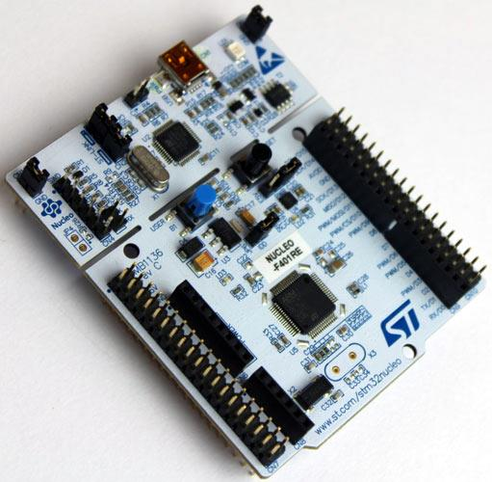

**Figure 1**: Pinout diagram of a STM32CubeIDE Nucleo-F401RE Board

**Apparatus:**

1) STM32 Cube IDE

2) STM32 Cube IDE board

3) LED lights (RED, GREEN, and YELLOW)

4) Three 200 ohms resistors

5) Jumper wires

**Experimental Procedure:**

First of all, we understood the theory and methodology of a STM32. Then we collected a STM32CubeIDE Nucleo board with some LED’s, resistors and jumper wires. The experiment was divided into two parts. The first part was LED light blinking. So, we took a Red Led and built the circuit according to the lab manual. Then we connected the STM32CubeIDE Nucleo board with the computer and burned the code for LED blinking into the board with the help of the IDE. We did the same thing for the Traffic Control System. We built the circuit according to the lab manual. Then we wrote the code for the Traffic Control System in in the STM32CubeIDE. Then we burned the code into the STM32CubeIDE.

**Hardware Pictures**

Traffic Control System

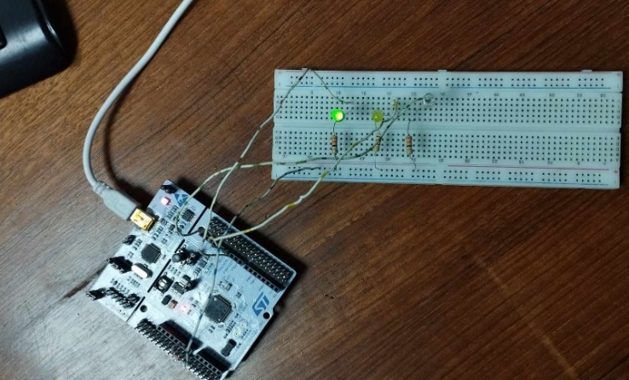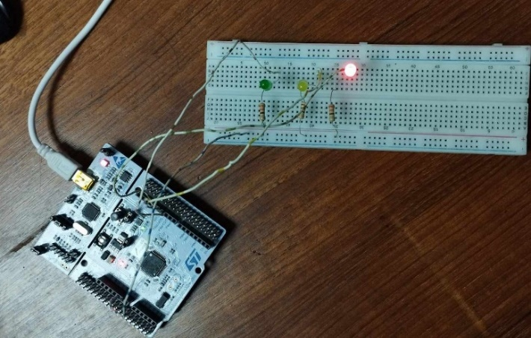

Green LED ON

Red LED ON

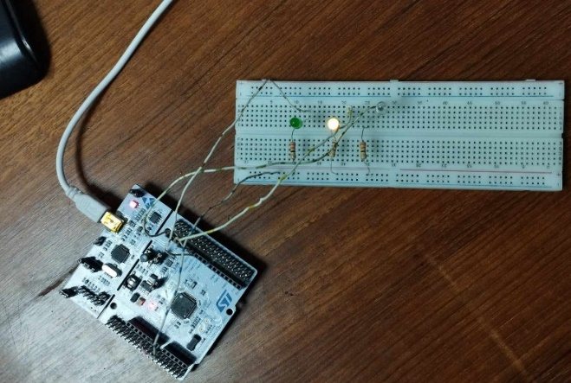

Yellow LED ON

Blinking LED Light

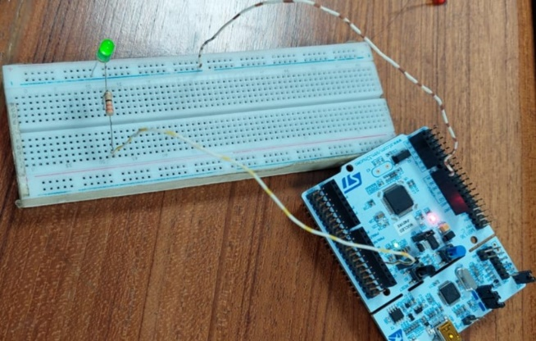

Green LED Blinking

**Discussion:**

In the conducted experiment, the primary focus was on understanding the functionality and application of the STM32 microcontroller through practical implementation. By initially grasping the theory and methodology of STM32, participants gained a foundational understanding of its capabilities and programming aspects. This knowledge served as a basis for effectively utilizing the STM32CubeIDE development platform, which facilitated the configuration, coding, and deployment processes. Through hands-on experience, participants familiarized themselves with essential tasks such as connecting the Nucleo board to the computer and programming it using the IDE, thereby reinforcing theoretical concepts through practical application.

The experiment was divided into two distinct parts: LED light blinking and Traffic Control System simulation. These divisions allowed participants to explore different aspects of microcontroller functionality and programming techniques. By constructing the LED circuit and writing code to control its blinking pattern, participants gained insight into basic input-output operations and GPIO configurations. Subsequently, the Traffic Control System simulation introduced more complex programming concepts, such as multi-tasking and sensor integration. By building the circuit and programming the STM32 microcontroller to simulate traffic light behavior, participants further honed their skills in system design and implementation, bridging the gap between theoretical knowledge and real-world applications.

Furthermore, the experiment provided valuable insights into the practical challenges and considerations involved in microcontroller-based projects. Participants encountered issues such as circuit connections, code debugging, and troubleshooting, which enhanced their problem-solving skills and critical thinking abilities. Additionally, by working through the experiment's stages, participants gained confidence in utilizing development tools like STM32CubeIDE and integrating various hardware components effectively. Overall, the experiment served as a hands-on learning experience that not only reinforced theoretical concepts but also equipped participants with practical skills essential for future projects in embedded systems and microcontroller programming.

**Conclusion:**

The experiment involving the STM32 microcontroller and STM32CubeIDE provided a hands-on learning experience that bridged theoretical concepts with practical application. Through tasks such as LED light blinking and Traffic Control System simulation, participants gained insight into microcontroller functionalities, GPIO configurations, and advanced programming techniques. The experiment not only enhanced problem-solving skills but also instilled confidence in utilizing development tools like STM32CubeIDE. Overall, this practical experience serves as a solid foundation for future endeavors in embedded systems and microcontroller programming, emphasizing the importance of hands-on learning in engineering education.

**Reference(s):**

* https://www.st.com/en/evaluation-tools/nucleo-f401re.html for STM32F401RE,datasheet
* [www.st.com](http://www.st.com)
* https://www.st.com/resource/en/user_manual/dm00105879-description-of-stm32f4-hal-and-ll-drivers-stmicroelectronics.pdf
* www.st.com/en/development-tools/stm32cubeide.html